AI TOOLS AND FRAMEWORKS
Theory questions
Q1:Difference between tensor flow and pythtorch
TensorFlow: Static computation graphs (define-then-run), better for production deployment, strong mobile support
PyTorch: Dynamic computation graphs (define-by-run), better for research and prototyping

When to choose
Choose TensorFlow for production systems, mobile apps, when you need TensorBoard
Choose PyTorch for research, rapid prototyping, when you want more Python-like code

Q2 cases for Jupyter Notebooks in AI dev
Data Exploration and Visualization: Jupyter allows interactive data analysis with immediate visualization of datasets, distributions, and patterns before model training.
Model Prototyping and Experimentation: Developers can quickly test different algorithms, hyperparameters, and architectures in isolated cells while documenting the process.

Q3 How does spaCy enhance NLP tasks compared to basic Python string operations
spaCy understands linguistic context and grammar while string operations only do pattern matching
spaCy performs part-of-speech tagging, dependency parsing, and entity recognition that string operations cannot
Example: spaCy can distinguish Apple the company and the fruit while string operations would treat them identically

Ethics
Q1 Identify potential biases in your MNIST or Amazon Reviews model
MNIST Bias: Only recognizes Western/Arabic numerals (0-9), trained primarily on North American/European handwriting styles, may not work well for other numeral systems or cultural writing styles
Amazon Reviews Bias: Only processes English text, trained on Western products and perspectives, rule-based sentiment analysis misses cultural context and sarcasm

Q2 How could tools like TensorFlow Fairness Indicators or spaCy's rule-based systems mitigate these biases
TensorFlow Fairness Indicators: Could measure accuracy differences across demographic groups, detect if model performs worse on certain writing styles or languages
spaCy rule-based systems: Could flag biased language, add cultural context rules, expand entity recognition to include diverse products and brands

IRIS DATASET

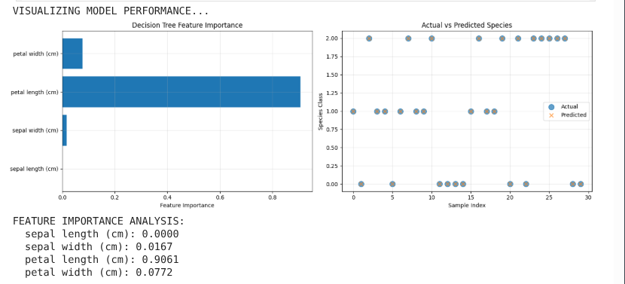

CNN DATA MODEL
